**Aim**

To demonstrate **virtualization** by installing a **Type-2 Hypervisor (Oracle VM VirtualBox)** and creating & configuring a Virtual Machine with a host operating system (Windows/Linux).

**Procedure**

1. **Install Hypervisor**
   * Download and install **Oracle VM VirtualBox** on the host machine.
2. **Launch VirtualBox**
   * Open the VirtualBox application.
3. **Create a New VM**
   * Click **New**, give a suitable name, and choose the guest OS type (Windows/Linux).
   * Allocate required RAM.
4. **Create Virtual Hard Disk**
   * Select **VDI (VirtualBox Disk Image)** → choose **Dynamically allocated** or **Fixed size** → set disk size.
5. **Attach ISO Image**
   * Go to **Settings → Storage** → attach the downloaded OS ISO file to the virtual optical drive.
6. **Configure Hardware**
   * Set processors, video memory, and network mode as needed.
7. **Start VM & Install OS**
   * Power on the VM, boot from ISO, and follow the installation steps of the selected operating system.
8. **Remove Installation Media & Reboot**
   * Detach the ISO after installation so the VM boots from its virtual hard disk.
9. **Install Guest Additions**
   * Insert Guest Additions CD image from VirtualBox menu for enhanced graphics, shared clipboard, and drag-drop.
10. **Verify Installation**
    * Confirm that the guest OS runs inside a window on the host and interacts properly.

**Output:**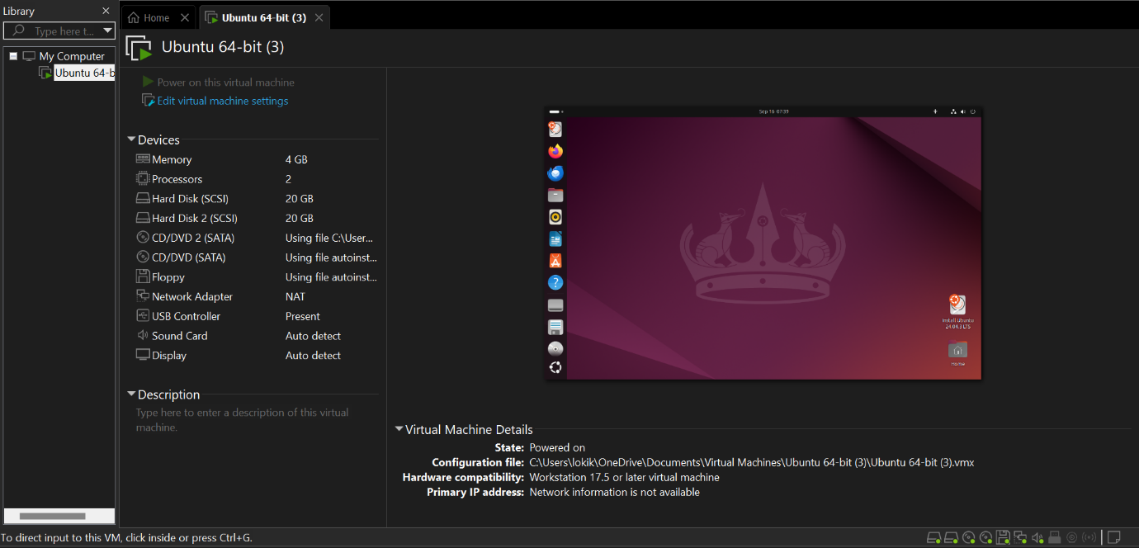

**Result:**

Virtualization was successfully demonstrated.  
A **Type-2 Hypervisor (VirtualBox)** was installed on the host system, and a fully functional **guest operating system** (Windows/Linux) was created and configured inside a virtual machine.